ACOF011, BABC011, CCOF001, DADC001, IITC001, EITC001, SATC001
ASSESSMENT ITEM BRIEF

Trimester | 3
Assessment Item Name | SMART goals, & Application to academic, social and professional contexts
Weighting | 10%
Due Date | Week 2

Assessment item description

A description of the assessment item is as follows:
In Week 1 of this course, you have been learning about SMART goals and your English language needs.
Assessment 1A Instructions
In this task, you will:
- Choose only one language skill (for example: reading, writing, listening, or speaking).
- Choose only one subskill (a smaller part of the skill, like vocabulary, grammar, pronunciation, or note-taking, etc).
- Write a SMART goal to improve this one skill and one subskill.
Then:
- Explain how this skill can help you in three areas:
  - Academic (for study)
  - Social (for everyday life)
  - Work (for your future job)
Finally:
- Write a reference list on a separate page.
Important:
Do not choose more than one skill or more than one subskill.
Your SMART goal must focus on just one skill and just one subskill.
Subject learning outcomes (SLOs) & Language learning outcomes (LLOs)
On successful completion of this assessment item, you should achieve the following outcomes:
SLO 3: | - earnestly (i) examine your own communication and study skills in academic, social and professional contexts and (ii) systematically apply academic conventions to maintain academic integrity

Assessment item brief

For this assessment item you are required to produce the following:
This assessment has three sections:
Section 1 – SMART goal
Section 2 – application
Section 3 (not graded) – References
You must answer all questions in Section 1 and Section 2 to pass.

Section 1: SMART Goal and Canvas Activities
- Choose only one language skill (reading, writing, listening, or speaking).
- Choose only one subskill (for example: vocabulary, grammar, note-taking, pronunciation).
- Write one sentence with your SMART goal to improve this skill and subskill.
- Think about problems or challenges you have with this skill.
- Find a module and activities on Canvas that can help you with these problems.

❗ Important:
Do not write about confidence, stress, time-management, motivation, or laziness. These are not language skills.

Section 2: Applying the Skill
Explain how your chosen skill helps you in:
- Academic life (e.g. college)
- Social life (e.g. talking with friends or in public)
- Work life (e.g. your future job or career)

Section 3: Reference List (Not Graded)
- Write a reference list on a separate page.
- Include the website of the job application you are interested in.

There are two options to complete this assessment

Option A | Option B
- Download the Word document and open the template.  - Fill in the template using the sentence starters provided.  - Do not change or delete any of the writing in the template, except:  - Replace the information inside the square brackets […] with your own.  - Replace the titles of the figures with your own titles.  - Replace the figures/images with your own.  - Remove the square brackets and dots when you add your own information.  - Submit the completed template when you are finished. | Create a video (maximum 4 minutes) with PowerPoint slides to answer each section of the template.  - For Section 1: put each question on a separate PowerPoint slide and answer each question orally.  - For Section 2: put each question on a separate PowerPoint slide and answer each question orally. Include the image of the advertisement on a PowerPoint slide.  - For section 3: include the reference of the website on a separate slide.  - Submit the video.  Note: you must be seen when speaking

NOTE: the word limit is only a guide.

Viva Voce (Short Interview)

After you submit your work, you may be asked to do a viva voce.
This is a short face-to-face meeting with your teacher or the academic coordinator.

In the viva voce, you will:
- Talk about your SMART goal and your answers.
- Explain how you chose your texts and images.
- Show that you understand your work and can talk about it clearly.

Section 1 – Criterion 1: SMART goals: Answer questions relating to the language skill you want to improve. |  |  | Teacher’s Grade
1 | Language skill and subskill / aspect.  State the language skill [speaking, reading, listening, writing] and subskill [pronunciation, scanning, listening for gist, sentence structure, etc.] have you chosen to improve.  You must focus on ONE language skill and ONE subskill.  Note: do not choose presentation skills, body language, public speaking, etc. as these are not specifically language skills – choose from speaking, reading, listening, writing, only. | Language skill: _writing ___________________________  Subskill: _developing an argument_________________ | Adequate  Inadequate  Missing
2 | Why do you think you need to improve this skill? Provide explicit, relevant reasons and examples. (75 words)  Do not write about confidence, stress, time-management, motivation, laziness, etc. – these do not relate to language skills) | The reason I would like to improve this skill and subskill is because it is a critical bridge connecting my current studies to my future goals. Success on my upcoming IELTS and GRE exams hinges on my ability to write well-structured, persuasive essays. This foundation will be vital in my Business Analytics master's program, where I must translate complex data into coherent arguments. Looking ahead to my career in financial analysis or management consulting, this skill becomes paramount. My primary role will be to construct robust, evidence-backed arguments to convince stakeholders of investment theses or strategic directions, making this the core of my professional value. | More than adequate  Adequate  Just adequate  Inadequate  Missing
3 | SMART goals  Write your SMART goal following the model you learnt in Module 1 of this course. ONE sentence only.  Do not write about confidence, stress, time-management, motivation, laziness, etc. – these do not relate to language skills) | By the end of this semester, I should be better able to strengthen my argument development in essays by consistently incorporating clear claims, logical reasoning, and supporting evidence, which will be reflected in achieving at least a "D" grade on subsequent writing assignments. | More than adequate  Adequate  Just adequate  Inadequate  Missing
4 | Potential problems (100 words)  Provide two problems/challenges that you might foresee while improving your language skill. The problems must directly relate to the language skill.  Do not write about confidence, stress, time-management, motivation, laziness, etc. – these do not relate to language skills) | The first potential challenge I foresee is evidence evaluation. This is the critical task of finding and assessing credible, scholarly sources to form a robust foundation for any claims. The difficulty is not merely locating information, but rigorously questioning its authority, potential bias, and accuracy. An argument built on weak, outdated, or inappropriate evidence is fundamentally flawed and cannot withstand academic scrutiny, making this skill essential.  The second potential problem I foresee is Structuring. This involves transforming a collection of initial ideas into a coherent, logical framework. The difficulty lies in formulating a clear and debatable thesis statement that serves as the argument's backbone, and then developing distinct topic sentences for each paragraph that directly support this central thesis. Without this deliberate structure, an argument can easily become disorganized and fail to guide the reader persuasively from the premise to the conclusion. | More than adequate  Adequate  Just adequate  Inadequate  Missing
5 | Ways to improve (100 words)  Considering the problems/challenges outlined in Question 4, skim the Modules on CANVAS of this subject. Choose ONE, and only one, module that relates to your chosen language skill.  - Choose TWO, and only two, activities/concepts in your chosen module that will help you overcome these problems/challenges. DO NOT choose Module 1.  - Clearly explain how the activities/concepts will help you overcome these problems/challenges.  Do not write about confidence, stress, time-management, motivation, laziness, etc. – these do not relate to language skills) | - To help me improve my language skill, I will look at the following module on CANVAS of this course.  - Module 5: Research  - Within this module, I will look at the following concepts and/or activities:  - Locating and selecting sources  - The research-writing cycle  - These concepts/activities will help me improve my language skill because …  - Studying Locating and selecting sources will directly help me overcome my evidence evaluation challenge. It will teach me how to move beyond basic searches to find scholarly materials in academic databases. More importantly, it will provide a framework for critical assessment, giving me a systematic way to rigorously question a source's authority, potential bias, and accuracy. Mastering this process will ensure the evidence I use is strong enough to withstand academic scrutiny.  - Using the research-writing cycle is a practical solution for my Structuring challenge. The cycle starts with the key step of "Formulating a research question". This is helpful because a strong question pushes me to find a specific, debatable answer, which is precisely the "clear and debatable thesis statement" I find hard to create. The diagram then shows the next logical step for building a framework is to "Make an outline". This step allows me to organize my thesis into clear topic sentences for each paragraph, ensuring I have a solid, logical structure before I start writing. | More than adequate  Adequate  Just adequate  Inadequate  Missing

Section 2: Application of SMART goal to an academic, a social, and a professional context (Work Integrated Learning). Answer questions relating to the how your language skill can be applied to different contexts.
Academic Context

Application chosen language skill to an academic context (100 words)  Choose a future assessment this semester (any subject).  Briefly summarise what you need to do for this assessment.  Explain how improving your chosen language skill will help you do well in that assessment task? | For my future assessment 3c: Essay or report, I will write a 1,200-word report that compares two texts using three selected CRAAP criteria to recommend which text better answers a research question. The report requires specific sections, including a justification for my choice and a counterargument addressing the text's limitations, each about 250 words.  Improving my skill in developing an argument is crucial for this task. The entire report is an extended argument for one text over the other. This skill is directly applied in the justification section to build a persuasive case and in the counterargument section to address weaknesses. Furthermore, every paragraph must use the TEEL structure (Topic, Explanation, Evidence, Link), which is a method for creating a well-supported argument. | More than adequate  Adequate  Just adequate  Inadequate  Missing

Social Context

Application of chosen language skill to a social context (100 words)  Describe a social experience/event which involves your friends or acquaintances (not your classmates at college).  Explain how improving your chosen language skill will enhance this social experience/event. | I often discuss future exchange and study abroad plans online with friends I met on a forum who share the same goals. We frequently compare programs in different countries and schools to help each other decide.  Improving my skill in developing an argument would make these discussions more effective. When we disagree, I could write a well-structured message to argue for my choice. For example, I could present a clear claim, use curriculum details or employment statistics as evidence, and analyze why a specific program better suits our long-term goals, helping our group make smarter, more informed decisions together. | More than adequate  Adequate  Just adequate  Inadequate  Missing

Professional context

Application of SMART goal to a professional context (WIL)

Find a recent (last month) job advertisement (one that directly relates to your Diploma program – science, animation, design, architecture, communication, engineering, IT, business) on a website.

For example, try https://www.seek.com.au

Reflect on how your chosen language skill relates to that job.

Provide a live URL of the job advertisement | URL: https://www.seek.com.au/job/87223438?ref=search-standalone&type=standard&origin=showNewTab#sol=da2b075ff7b0ac78fdad6927cdd7ec1208551b98 | Ungraded
Delete the figure provided.  Provide a screenshot of the main part of the advertisement.  Provide your own title; use italics. | Figure 1  Job advertisement for Reporting Analyst at La Trobe Financial   | More than adequate  Adequate  Just adequate  Inadequate  Missing
Relevance to your program: (About 75 words)  Identify your specific Diploma Program at UTS College.  Explain how this job connects to your program. | I am enrolled in the Information Management and Information Systems Program.  This job is connected to this program because this Reporting Analyst role is focused on translating raw data into actionable insights for stakeholders. My program in Information Management and Information Systems teaches exactly this—how to use technology and BI systems to analyze information for business use. The position's emphasis on data transformation, BI tools, and assisting with the implementation of BI systems directly aligns with the technical and analytical skills I am developing. | More than adequate  Adequate  Just adequate  Inadequate  Missing
Delete the figure provided.  Provide a screenshot of part of the advertisement that mentions your chosen language skill.  Highlight this point. For example: “excellent verbal and written communication skills”.  Provide your own title; use italics | Figure 2  Job description for a reporting analyst that requires excellent writing skills  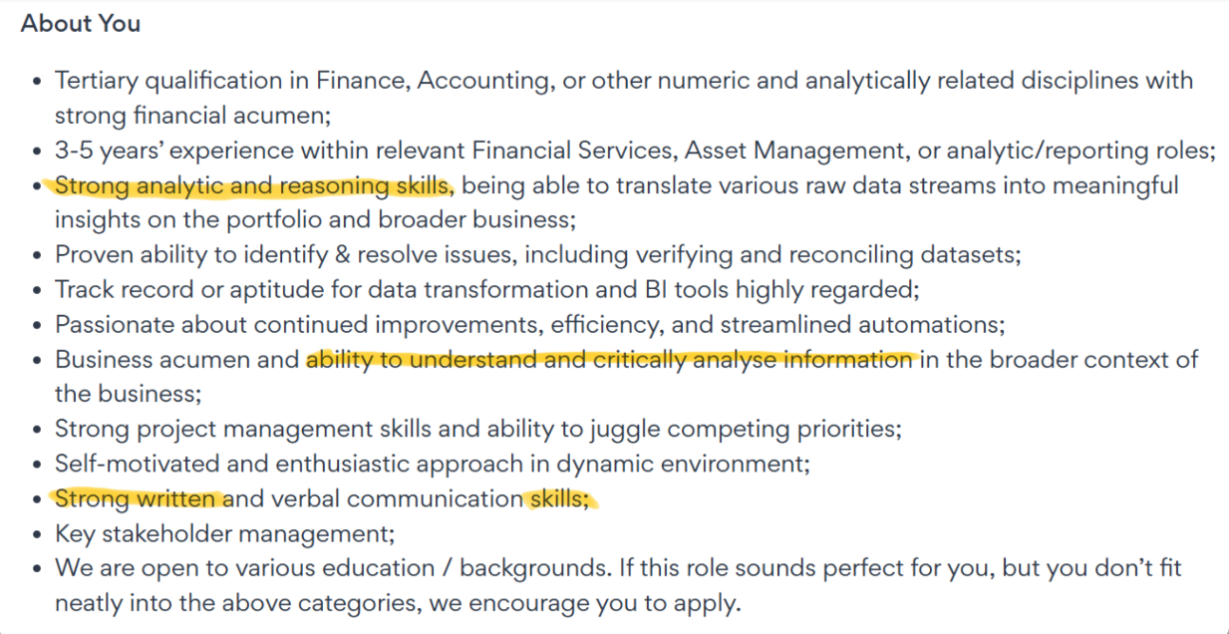 | More than adequate: highlighted and appropriate  Adequate: highlighted and generally appropriate  Just adequate: not highlighted but appropriate or generally appropriate  Inadequate: no reference to language  Missing
Relevance to your language skill: (About 75 words).  Delete the figure provided.  Provide a screenshot of the activities listed in the advertisement that you will need to do.  Identify ONE specific activity. Highlight it.  Explain why your chosen language skill is essential for this activity. | Figure 3  Activity  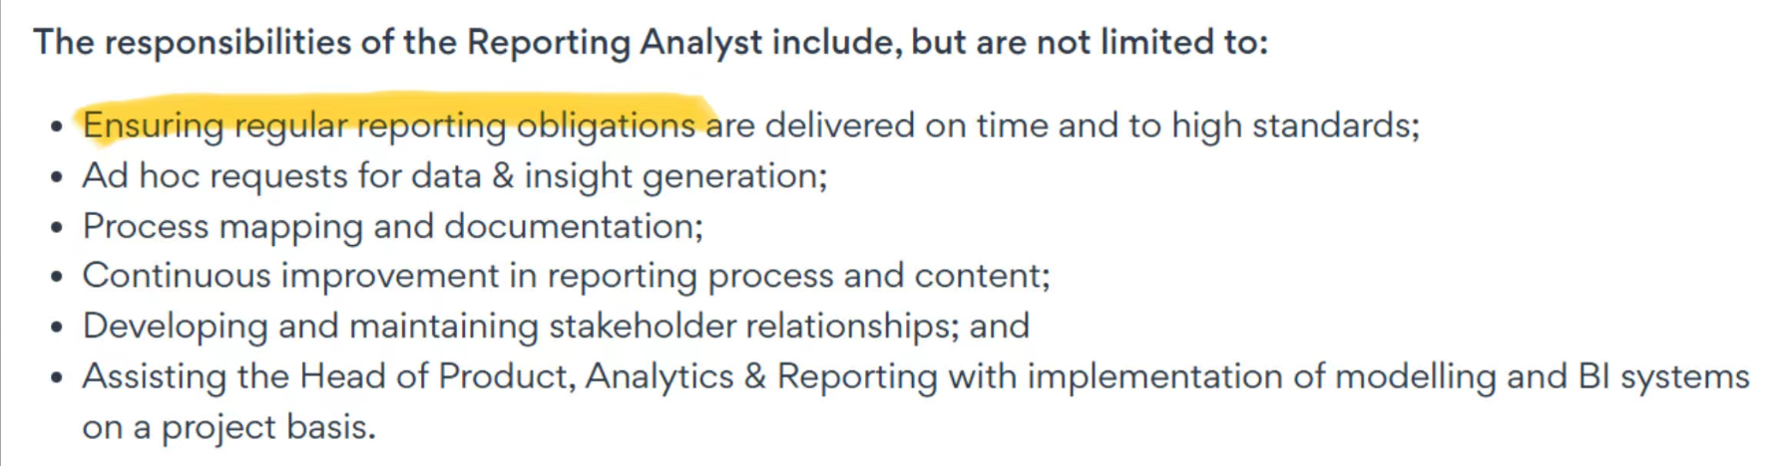  The activity is Ensuring regular reporting obligations are delivered on time and to high standards. My chosen language skill is necessary to complete this activity because a report delivered to a "high standard" is more than just a list of data; it is a well-structured written argument. My writing skills are essential for organizing complex information, presenting a key finding as the main claim, and using data as evidence to support that claim. This ensures the final report is a clear, persuasive, and insightful document for stakeholders. | More than adequate  Adequate  Just adequate  Inadequate  Missing

Section 3: Reference list (note, all assessments must have a reference list. However, you have not learnt how to write references using APA 7th edition style, so this is practice only. You will get feedback for Assessment 2.
- Write a reference list.

- Include the website on which you read the job advertisement.

- Use APA 7th edition style.

- Align the reference to the left.

- Double space.

- Use a hanging indent.

- Follow the example below.

Example of a website:

Organisation. (Year, Month Day). Title of webpage. Title of Website. URL

Write your references list below under “References”.

References

Seek. (2025, September 16). Reporting Analyst- La Trobe Financial. Seek
https://www.seek.com.au/job/87223438?ref=search-standalone&type=standard&origin=showNewTab#sol=da2b075ff7b0ac78fdad6927cdd7ec1208551b98

Assessment item grading criteria

For this assessment item you will be graded according to the following criteria:
CRITERIA | HD | D | C | P | F | F0
Section 1  Manage Learning |GC001  Evaluate and manage learning to enable life-long independent language learning (SMART goals) | At least two answers are more than adequate; others are adequate. | Demonstrates more than adequately the ability to evaluate and manage learning to enable life-long independent language learning (SMART goals). That is, at least one answer is more than adequate; others are adequate. | All answers are adequate. | Demonstrates more than just adequately the ability to evaluate and manage learning to enable life-long independent language learning (SMART goals). At least one answer is adequate or above; others are just adequate. | Not all aspects of P grade are achieved; ... OR ... task requirements, as stated in the assessment brief, were not met | No submission, or there is so little text that it can be considered a non-submission
Section 2  Work Integrated Learning GC002|  Transfer language learning strategies to an academic and a professional context (WIL) | At least two contexts are more than adequate; the other is adequate. | Demonstrates more than adequately the ability to transfer language learning strategies to an academic and a professional context (WIL). That is, one context is more than adequate; others are adequate. | All contexts are adequate. | Demonstrates more than just adequately the ability to transfer language learning strategies to an academic and a professional context (WIL). That is, at least one context is adequate or above; others may be just adequate. | Not all aspects of P grade are achieved; ... OR ... task requirements, as stated in the assessment brief, were not met | No submission, or there is so little text that it can be considered a non-submission

More than adequate: the answer addresses the question in a way that demonstrates that the student has clearly understood the task and the concepts, the answer showing insight and development.
Adequate: the answer demonstrates that the student has understood the task and the concepts, but the answer requires more insight and development
Just adequate: while there may be nothing explicitly wrong with the answer, it may be generic, lack insight and development; there may be gaps in the students’ understanding of the task or concepts.
Inadequate: the answer may be wrong or too scant, or there may be no apparent understanding of the task or concepts.

